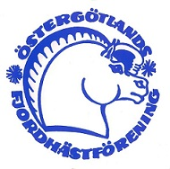 RESULTAT PAY AND RIDE 8 APRIL STALL EKÄNGEN

LD:3 2011
1. Elin Norr – Dextelit 61.11 %
2. Susanne Söderlund – Fancy Nancy 59.72 %

LC:2 2015
3. Annelie Södervall – Joker 58.16 %
4. Alice Åhlin – Emerald Dani 62.66 %
5. Sara Hellsten – Magnus 64.66 %

LB:1 2015
6. Caroline Pettersson – Tomas 59.64%
7. Ella Sedihn – Lada 58.92 %
8. Oliva Stridh – Timjan 63.92 %
9. Maria Nilsson – Bandra 58.03 %
10. Nina Flyght – Frode 62.32 %
11. Josefine Rodestrand – Ferrero 67.14 %
12. Marianne Lokrantz – Quenin 58.64 %

LA:1 2017
13. Josephine Löfving – Prince 61.66 %
14. Nina Flyght – Frode 56.80 %
15. Josefin Södervall – Joker 58.61 %

